19/11/19
THM 121 Business Mathematics
Midterm Exam Answer Sheet
Note to the students:
- Calculations to reach your answers shall be thoroughly shown. Otherwise, questions will NOT be graded.
- You can use a calculator throughout the exam.
- Factor and simplify the given expression as much as possible: (2 Points)
χ² + 2 χ + 1 – y²
χ² + 2 χ + 1 – y² = (χ + 1)² - y² = (χ + 1 + y) (χ + 1 – y)
- Simplify the given rational expression: (2 Points)
(2 - χ) / (χ² - 4)
(2 - χ) / (χ² - 4) = (2 – χ) / [(χ – 2) (χ + 2)] = [-(χ – 2)] / [(χ – 2) (χ + 2)]. Assuming that χ ≠ 2 and -2, we can simplify the numerator and denominator by dividing with (χ – 2). Hence, we get, -1 / (χ + 2)
- Factor the given polynomial using integer coefficients: (2 Points)
χ³ + 5χ² + 6χ
χ³ + 5χ² + 6χ = χ [χ² + 5χ + 6] = χ (χ + 2) (χ + 3)
- Solve the following quadratic equation by completing the square: (2 Points)
2χ² + 20χ + 42 = 0
2χ² + 20χ + 42 = 0 ↔ χ² + 10χ + 21 = 0 ↔ χ² + 10χ = - 21 ↔ χ² + 10χ + (20/4)² = - 21 + (20/4)² ↔ χ² + 10χ + 25 = - 21 + 25 ↔ (χ + 5)² = 4 ↔ either χ + 5 = 2 OR – (χ + 5) = 2 ↔ either χ = - 7 OR χ = - 3.
- Use the quadratic formula to solve the following equation: (2 Points)
9ϳ² - 4 = 3+ 9ϳ
9ϳ² - 4 = 3+ 9ϳ ↔ 9ϳ² – 9j – 7 = 0; ∆ = (-9)² – 4 (9) (-7) = 81 + 252 = 333 ↔ . Therefore, there are 2 solutions for this quadratic equation. These are as follows:
Either j = (9 - ) / 18 or j = (9 + ) / 18.
- Solve the given system of equations: (3 Points)
-2χ - 3y = 5 AND 6 χ + 2y = - 1
-2χ - 3y = 5 (i) AND 6 χ + 2y = - 1 (ii)
6 χ + 2y = - 1 ↔ y = (- 1 – 6 χ) / 2
Substituting y for (- 1 – 6 χ) / 2 in (i) gives us: - 2χ – 3((- 1 – 6 χ) / 2) = 5 ↔ - 2χ + 3/2 + 9χ = 5 ↔ 7χ = 7/2 ↔ χ = ½. Therefore y = (-1 – 6 (1/2)) / 2 = - 2.
- Evaluate the given sum: (2 Points)

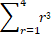
= 1³ + 2³ + 3³ + 4³ = 1 + 8 + 27 + 64 = 100.
- Express the given sum in term of summation notation: (2 Points)
(1/8) + (1/16) + (1/32) + (1/64)
(1/8) + (1/16) + (1/32) + (1/64) = (1/2³) + (1/2⁴) + (1/2⁵) + (1/2⁶) =
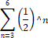
- Find the composite function ƒ(g(u)) such that: (2 Points)
ƒ(u) = -2u + 9 AND g(u) = -4 u² + 5u - 3
ƒ(g(u) = ƒ (-4 u² + 5u – 3) = -2 (-4 u² + 5u – 3) + 9 = 8u² – 10u + 6 + 9 = 8u² – 10u + 15.
- Suppose the total cost of manufacturing q units of a certain product is C (q) thousand dollars, where:
C (q) = 0.05q² + 0.80 q + 10
- Find the total cost and average cost of producing 15 units. (2 Points)
- Total cost of producing 15 units = C (15) = 0.05 (15)² + 0.80 (15) + 10 = 11.25 + 12 + 10 = 33.25.
Therefore, the total cost of producing 15 units is $ 33,250.
- Average cost per unit when 15 units are manufactured is: C (15) / 15 = 33,250 / 15 = $ 2,216.67.
(b) Find the cost of producing the 15th unit. (1 Point)
The cost of producing the 15th unit is C (15) – C (14) = 0.05 (15² - 14²) + 0.80 (15 – 14) = 0.05 * 29 + 0.80 = 1.45 + 0.80 = 2.25.
Therefore, the cost of producing the 15th unit is $ 2,250.
- A company that makes a certain brand of radios has fixed costs of $ 25,000 and variable costs of $ 7 per item produced. The company sells is radios for $ 18 each:
- What is C (q) (i.e. Cost function of quantity q produced)? (1 Point)
C (q) = 7 q + 25000
- What is R (q) (i.e. Revenue function of quantity q sold)? (1 Point)
R (q) = 18 q
- Graph the functions C (q) and R (q) on the same coordinate axis. (2 Points)
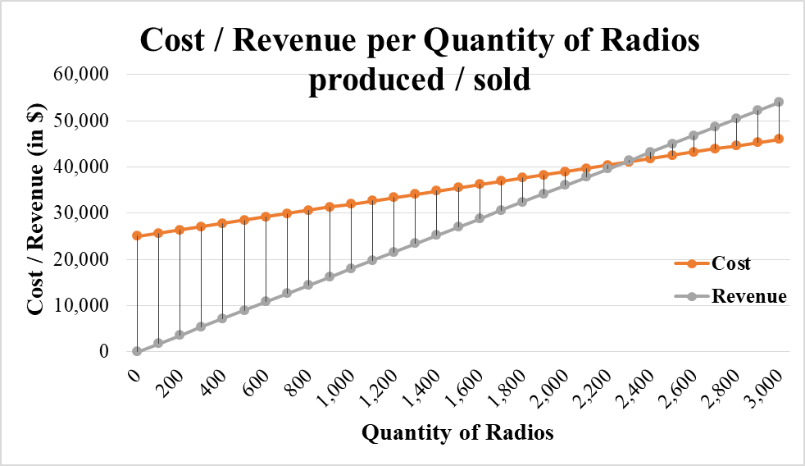
- Find the coordinates of the point of intersection of C (q) and R (q) functions? What is the economic significance of this very point? (2 Points)
The point of intersection shall be the point where C (q) and R (q) equates. This means when:
7 q + 25000 = 18 q ↔ 11 q = 25000 ↔ q = 25000 / 11 ↔ q ≈ 2,272.73 radios.
At 2,272.73 radios C (q) = 7 * 2272.73 + 25000 = $ 40,909.09. Moreover R (q) = 18 * 2272.73 = $ 40,909.09.
Thus, the point of intersection is (2272.73, 40909.09).
Economically, this point is referred to as the break-even point (i.e. the quantity where cost and revenue equates).
- If an object is thrown vertically upward from the ground with an initial speed of 50 meters per second, its height (in meters) t seconds later is given by the function:
H (t) = -3t² + 120t +50
- Sketch the graph of H (t). (2 Points)
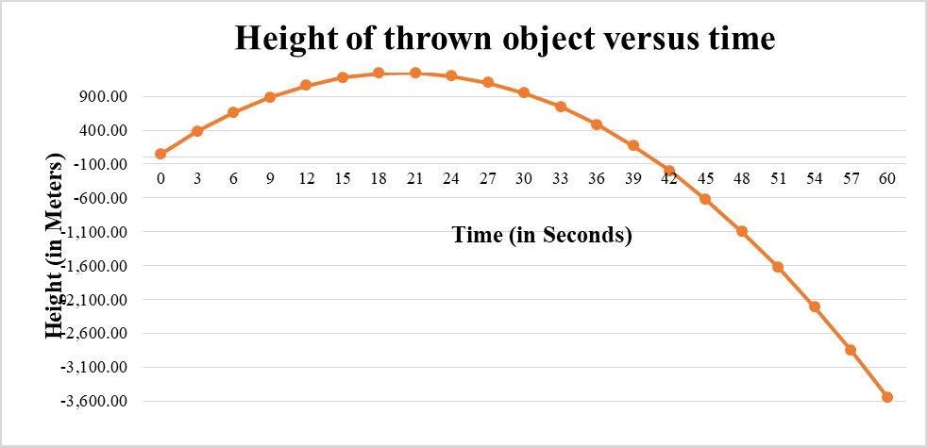
- When will the object hit the ground? (2 Points)
The object will hit the ground when H(t) = 0 ↔ -3t² + 120t +50 = 0; ∆ = (120)² – 4 (-3) (50) = 14400 + 600 = 15000 ↔ . Therefore, there are 2 solutions to this quadratic equation as follows:
Either t = (-120 - ) / -6 or t = (-120 + ) / -6 ↔ either t = (60 + ) / 3 or t = 60 - ) / 3. Practically, since the second answer yields a negative number and time cannot be negative, the object will hit the ground 40.41 seconds after it is thrown vertically.
- What is the maximum height that the object can reach? (1 Point)
The maximum height that the object can reach occur at the vertex (-b/2a) or at t = -120 / (-6) = 20 seconds. At this very time, the height reaches -3 (20)² + 120 (20) + 50 = -1200 + 2400 + 50 = 1250. Therefore, the maximum height that the object can reach is 1,250 meters.
GOOD LUCK!

